Nested Loop Join
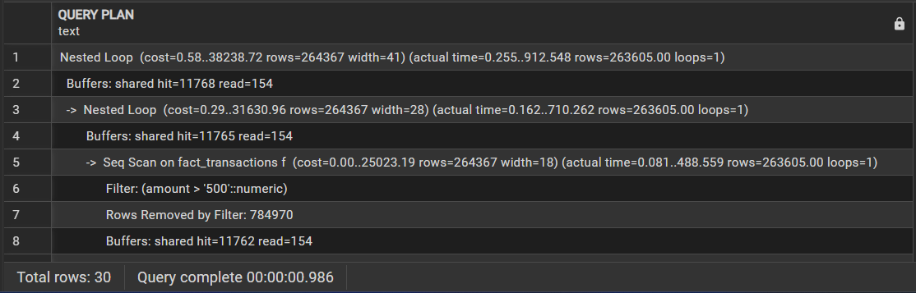
Sort Merge Join
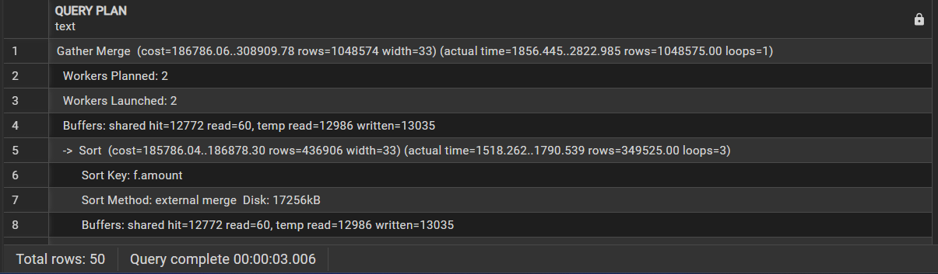
Hash Join
